Course: COSC457.101 – Database Management Systems

Instructor: Leon Bernard

Room: YR-304

Assignment #3

Please create the database in the textbook page 72 (which has 6 tables) and write SQL script (Please use MySQL. Workbench is optional). You can use create and insert scripts from Lab session.

Please hand in table creation script, question itself with the question number, SQL statement, and the query result for each question. Please use only standard SQL.

Note: you can copy and paste the queries and answer tables and then past those in Word document

(a) Retrieve the names of employee in department 5 who work more than 10 hours per week on the ‘ProductX’ project. (2 points)

***Query***

SELECT Fname,Lname

FROM EMPLOYEE e

INNER JOIN WORKS_ON wo on e.Ssn = wo.Essn

INNER JOIN PROJECT p on p.Pnumber = wo.Pno

WHERE p.pname ='ProductX'

and Hours > 10

and dno =5 ;

***Results***

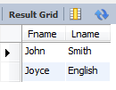

(b) List the names of employees who have a dependent with the same first name as themselves. (2 points)

***Query***

SELECT Fname, Lname

FROM EMPLOYEE e

INNER JOIN DEPENDENT d on e.Ssn = d.Essn

WHERE e.Fname = d.Dependent_name;

***Results***



(c) Find the names of employees that are directly supervised by ‘Franklin Wong’. (2 points)

***Query***

SELECT e.Fname,e.Lname

FROM EMPLOYEE e

INNER JOIN EMPLOYEE es on e.Super_ssn = es.ssn

WHERE es.Fname ='Franklin'

and es.Lname = 'Wong';

***Results***

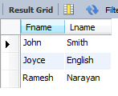

(d) For each project, list the project name and the total hours per week (by all employees) spent on that project. (2 points)

***Query***

SELECT Pname, Sum(Hours) as Total_Hours_per_week

FROM PROJECT p

INNER JOIN WORKS_ON w on p.Pnumber = w.Pno

GROUP BY Pname

***Results***

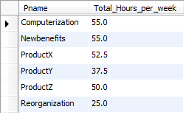

(e) Retrieve the names of employees who do not work on any project.

***Query***(4 points)

SELECT e.Fname,e.Lname

FROM EMPLOYEE e

WHERE e.ssn

not in (

SELECT Essn

FROM WORKS_ON

);

***Results***



(f) For **each** department, retrieve the department name, and the average salary of employees working in that department.

***Query*** (2 points)

SELECT Dname, AVG(Salary) as Average_Salary

FROM EMPLOYEE e

INNER JOIN DEPARTMENT d on e.Dno = d.Dnumber

GROUP BY Dname

***Results***

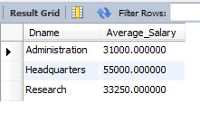

(g) Retrieve the average salary of all female employees. (2 points)

***Query***

SELECT AVG(Salary) as Average_Salary

FROM EMPLOYEE e

WHERE e.Sex ='F'

***Results***



(h) Find the names and addresses of employees who work on at least one project located in Houston but whose department has no location in Houston. (4 points)

***Query***

SELECT e.Fname,e.Lname,Address

FROM EMPLOYEE e

INNER JOIN WORKS_ON w on e.ssn = w.essn

INNER JOIN PROJECT p on p.Pnumber = w.Pno

WHERE Plocation ='Houston' and e.Dno not in (SELECT Dnumber from DEPT_LOCATIONS WHERE Dlocation ='Houston');

***Results***

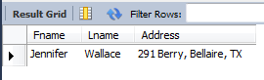

(i) List the last names of department managers who have no dependents. (4 points)

***Query***

SELECT e.Lname

FROM EMPLOYEE e

INNER JOIN DEPARTMENT d on e.ssn = d.Mgr_ssn

WHERE e.ssn not in (select essn from DEPENDENT);

***Results***



(j) Find the names of employees and the names of the projects that the employees are working on. (2 points)

***Query***

SELECT e.Fname,e.Lname,Pname

FROM EMPLOYEE e

INNER JOIN WORKS_ON w on e.ssn = w.essn

INNER JOIN PROJECT p on p.Pnumber = w.Pno;

***Results***

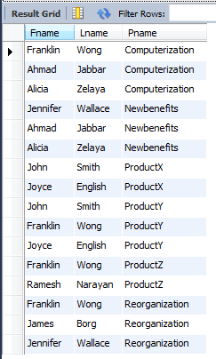

(k) Find the names of employees who are not working on the project that is not controlled by the employee’s own department. (Employees who work on only the employee’s own department’s projects). (4 points)

***Query***

Select e.Fname,e.Lname

FROM EMPLOYEE e

INNER JOIN WORKS_ON w on e.ssn = w.essn

INNER JOIN PROJECT p on p.Pnumber = w.Pno

INNER JOIN DEPARTMENT d on d.Dnumber = p.Dnum

WHERE e.ssn

not in (

select e.ssn

FROM EMPLOYEE e

INNER JOIN WORKS_ON w on e.ssn = w.essn

INNER JOIN PROJECT p on p.Pnumber = w.Pno

INNER JOIN DEPARTMENT d on d.Dnumber = p.Dnum

WHERE d.Dnumber <> e.Dno);

***Results***

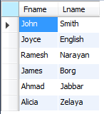

***Query***

SELECT Distinct e.Fname,e.Lname

FROM EMPLOYEE e

INNER JOIN WORKS_ON w on e.ssn = w.essn

INNER JOIN PROJECT p on p.Pnumber = w.Pno

INNER JOIN DEPARTMENT d on d.Dnumber = p.Dnum

WHERE d.Dnumber <> e.Dno;

***Results***

